**Chapter 3**

**Derivatives**

**3.4 Derivatives as Rates of Change**

**Section Exercises**

**For the following exercises, the given functions represent the position of a particle traveling along a horizontal line.**

1. **Find the velocity and acceleration functions.**
2. **Determine the time intervals when the object is slowing down or speeding up.**

151. 

Answer: a. b. speeds up  slows down 

153. A rocket is fired vertically upward from the ground. The distance in feet that the rocket travels from the ground after  seconds is given by 

1. Find the velocity of the rocket 3 seconds after being fired.
2. Find the acceleration of the rocket 3 seconds after being fired.

Answer: a.  b. 

155. The position function  represents the position of the back of a car backing out of a driveway and then driving in a straight line, where  is in feet and  is in seconds. In this case,  represents the time at which the back of the car is at the garage door, so  is the starting position of the car, 4 feet inside the garage.

1. Determine the velocity of the car when 
2. Determine the velocity of the car when 

Answer: a. 5 ft/s b. 9 ft/s

157. A potato is launched vertically upward with an initial velocity of 100 ft/s from a potato gun at the top of an 85-foot-tall building. The distance in feet that the potato travels from the ground after  seconds is given by 

1. Find the velocity of the potato after  and .
2. Find the speed of the potato at 0.5 s and 5.75 s.
3. Determine when the potato reaches its maximum height.
4. Find the acceleration of the potato at 0.5 s and 1.5 s.
5. Determine how long the potato is in the air.
6. Determine the velocity of the potato upon hitting the ground.

Answer: a. 84 ft/s, –84 ft/s b. 84 ft/s c. d.  in both cases e.  f. 

159. The following graph shows the position  of an object moving along a straight line.

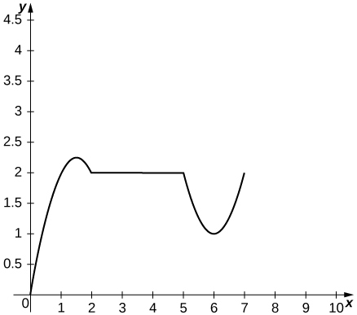

1. Use the graph of the position function to determine the time intervals when the velocity is positive, negative, or zero.
2. Sketch the graph of the velocity function.
3. Use the graph of the velocity function to determine the time intervals when the acceleration is positive, negative, or zero.
4. Determine the time intervals when the object is speeding up or slowing down.

Answer: a. Velocity is positive on  negative on  and zero on 

b.

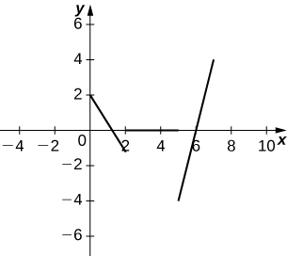

c. Acceleration is positive on  negative on  and zero on 

d. The object is speeding up on  and slowing down on 

161. The price  (in dollars) and the demand  for a certain digital clock radio is given by the price–demand function 

1. Find the revenue function 
2. Find the marginal revenue function.
3. Find the marginal revenue at  and 

Answer: a.  b.  c. $6 per item, $0 per item]

163. [**T**]In general, the profit function is the difference between the revenue and cost functions: 

Suppose the price-demand and cost functions for the production of cordless drills is given respectively by and where  is the number of cordless drills that are sold at a price of  dollars per drill and  is the cost of producing  cordless drills.

1. Find the marginal cost function.
2. Find the revenue and marginal revenue functions.
3. Find  and . Interpret the results.
4. Find the profit and marginal profit functions.
5. Find  and . Interpret the results.

Answer: a.  b.  c.  At a production level of 1000 cordless drills, revenue is increasing at a rate of $83 per drill; at a production level of 4000 cordless drills, revenue is decreasing at a rate of $97 per drill. d. e.  At a production level of 1000 cordless drills, profit is increasing at a rate of $18 per drill; at a production level of 4000 cordless drills, profit is decreasing at a rate of $162 per drill.

165.[**T**]A culture of bacteria grows in number according to the function  where  is measured in hours.

1. Find the rate of change of the number of bacteria.
2. Find and 
3. Interpret the results in (b).
4. Find  and  Interpret what the answers imply about the bacteria population growth.

Answer: a.  b.  c. The bacteria population increases from time 0 to 10 hours; afterwards, the bacteria population decreases. d.  The rate at which the bacteria is increasing is decreasing during the first 10 hours. Afterwards, the bacteria population is decreasing at a decreasing rate.

**The following questions concern the population (in millions) of London by decade in the 19th century, which is listed in the following table.**

**Population of London**

|  |  |
| --- | --- |
| Years since 1800 | Population (millions) |
| 1 | 0.8795 |
| 11 | 1.040 |
| 21 | 1.264 |
| 31 | 1.516 |
| 41 | 1.661 |
| 51 | 2.000 |
| 61 | 2.634 |
| 71 | 3.272 |
| 81 | 3.911 |
| 91 | 4.422 |

167. [**T**]

1. Using a calculator or a computer program, find the best-fit linear function to measure the population.
2. Find the derivative of the equation in a. and explain its physical meaning.
3. Find the second derivative of the equation and explain its physical meaning.

Answer: a.  b.  The population is increasing. c.  The rate at which the population is increasing is constant.

**For the following exercises, consider an astronaut on a large planet in another galaxy. To learn more about the composition of this planet, the astronaut drops an electronic sensor into a deep trench. The sensor transmits its vertical position every second in relation to the astronaut’s position. The summary of the falling sensor data is displayed in the following table.**

|  |  |
| --- | --- |
| Time after dropping (s) | Position (m) |
| 0 | 0 |
| 1 | –1 |
| 2 | –2 |
| 3 | –5 |
| 4 | –7 |
| 5 | –14 |

169. [**T**]

1. Using a calculator or computer program, find the best-fit quadratic curve to the data.
2. Find the derivative of the position function and explain its physical meaning.
3. Find the second derivative of the position function and explain its physical meaning.

Answer: a.  b.  This is the velocity of the sensor. c.  This is the acceleration of the sensor; it is a constant acceleration downward.

**The following problems deal with the Holling type I, II, and III equations. These equations describe the ecological event of growth of a predator population given the amount of prey available for consumption.**

171. **[T]** The Holling type I equation is described by  where  is the amount of prey available and  is the rate at which the predator meets the prey for consumption.

1. Graph the Holling type I equation, given 
2. Determine the first derivative of the Holling type I equation and explain physically what the derivative implies.
3. Determine the second derivative of the Holling type I equation and explain physically what the derivative implies.
4. Using the interpretations from b. and c. explain why the Holling type I equation may not be realistic.

Answer: a.

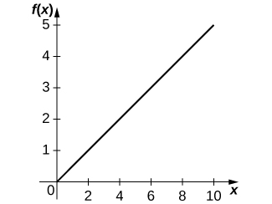

b.  The more increase in prey, the more growth for predators.

c.  As the amount of prey increases, the rate at which the predator population growth increases is constant.

d. This equation assumes that if there is more prey, the predator is able to increase consumption linearly. This assumption is unphysical because we would expect there to be some saturation point at which there is too much prey for the predator to consume adequately.

173. **[T]** The Holling type III equation is described by  where  is the amount of prey available and  is the maximum consumption rate of the predator.

1. Graph the Holling type III equation given  and  What are the differences between the Holling type II and III equations?
2. Take the first derivative of the Holling type III equation and interpret the physical meaning of the derivative.
3. Find and interpret the meaning of the second derivative (it may help to graph the second derivative).
4. What additional ecological phenomena does the Holling type III function describe compared with the Holling type II function?

Answer: a.

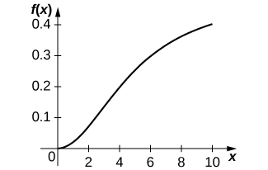

b.  When the amount of prey increases, the predator growth increases.

c.  When the amount of prey is extremely small, the rate at which predator growth is increasing is increasing, but when the amount of prey reaches above a certain threshold, the rate at which predator growth is increasing begins to decrease.

d. At lower levels of prey, the prey is more easily able to avoid detection by the predator, so fewer prey individuals are consumed, resulting in less predator growth.

This file is copyright 2016, Rice University. All Rights Reserved.